Introduction
In this project, I performed an in-depth analysis of retail order data using SQL and Python to generate meaningful business insights. The objective was to understand revenue trends, product performance, regional sales distribution, and year-over-year growth patterns.
The analysis focused on solving key business problems such as:
- Identifying the Top 10 highest revenue-generating products to understand best-performing items.
- Determining the Top 5 highest-selling products in each region to analyze regional demand patterns.
- Performing Month-over-Month sales growth comparison for 2022 and 2023 to evaluate sales performance trends.
- Finding the highest sales month for each product category to identify seasonal performance.
- Analyzing which sub-category achieved the highest profit growth in 2023 compared to 2022 to measure business expansion.
Through this analysis, I applied advanced SQL concepts including:
- Aggregations (SUM, GROUP BY)
- Window functions (RANK)
- Year-over-Year comparison
- Growth percentage calculations
- Business-focused data insights
This project demonstrates my ability to transform raw retail data into actionable insights using SQL-driven analysis techniques.
1.Find the Top 10 highest revenue generated product
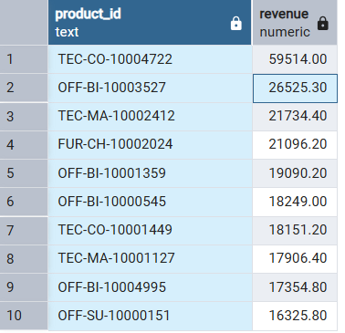
2. Find the top 5 highest selling product in each region
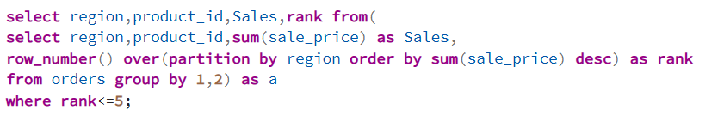
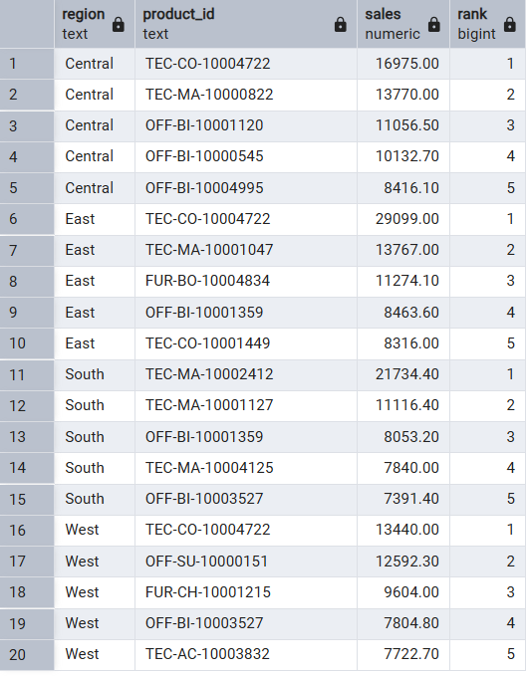
3. find month over month growth comparison for 2022 and 2023 sales
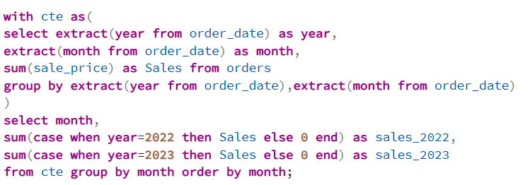
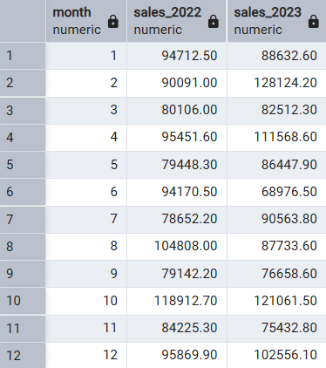
4. For each category which month had highest sales
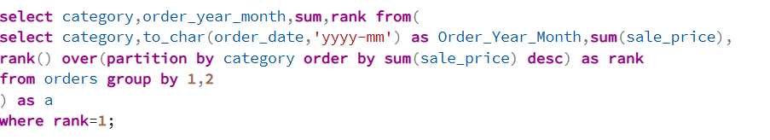
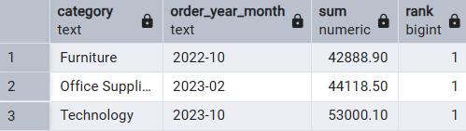
5. which sub category had highest growth by profit in 2023 compare to 2022
